Title :

Retrieval-Augmented Intelligent Legal Assistant for Court Judgments

Abstract :

The large number of court judgments available online makes it difficult and time-consuming to find useful legal information. This project presents a Retrieval-Augmented Intelligent Legal Assistant for Court Judgments using machine learning and text analytics. The main aim of the system is to help users quickly find relevant information from court judgments and get simple answers to their legal queries. The system uses Natural Language Processing (NLP) to clean and process legal documents. It then converts the documents into numerical representations and uses semantic search to find the most relevant sections. These retrieved sections are provided to a language model, which generates a clear and useful response based on the available information. The system can also help with finding similar cases, summarizing judgments, and answering questions. This project shows how machine learning and text analytics can be applied to make legal research faster, easier, and more accessible.

Datasets :

Dataset | URL link
ILDC – Indian Legal Documents Corpus | https://aclanthology.org/2021.acl-long.313/?utm_source=chatgpt.com
COLIEE Case Law Dataset | https://coliee.org/?utm_source=chatgpt.com
IndianBailJudgments-1200 | https://arxiv.org/abs/2507.02506?utm_source=chatgpt.com

Approach :

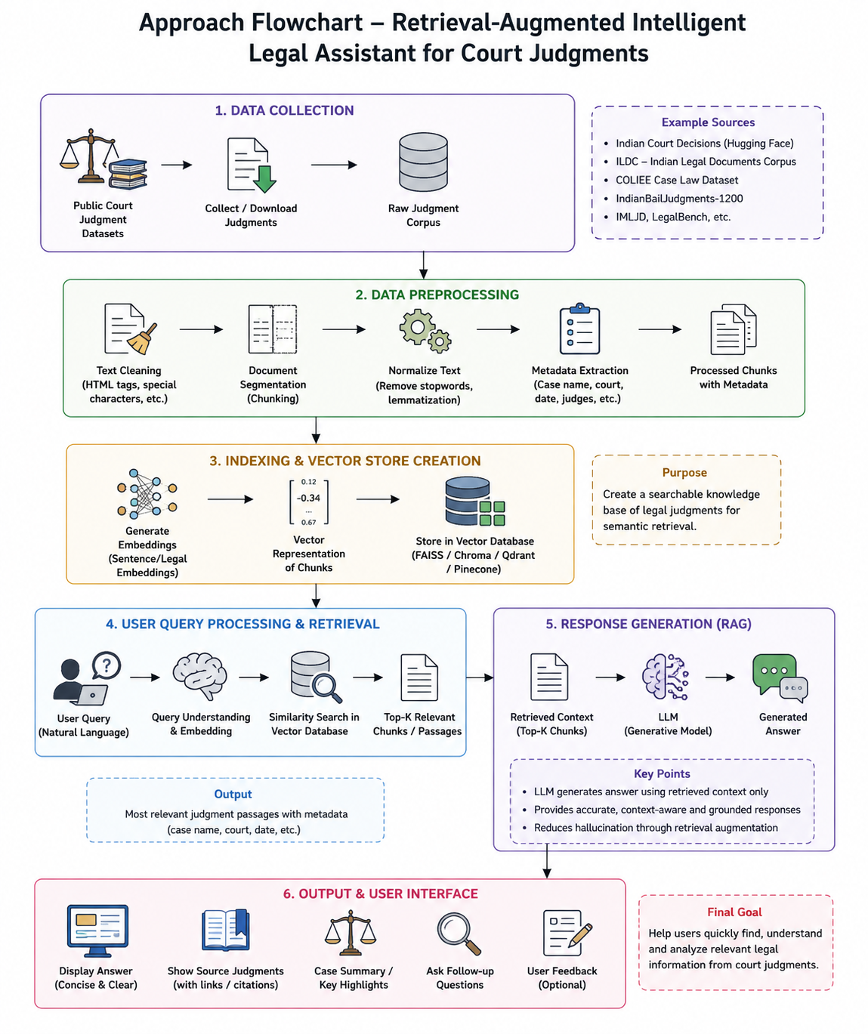

Project Group Members :

S.No Name Roll Number

- A.Sahasra 2420090091

- K.P.Shreya 2420090093

- V.Gowrie 2420030298

- K.Ishta 2420039803

